July 2019 Newsletter

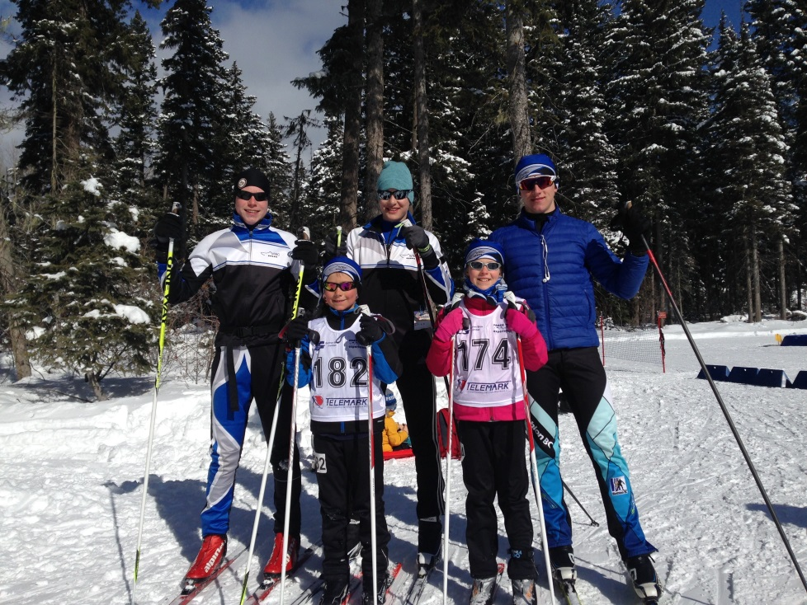
VIBC Athletes at Biathlon BC Provincial Championships

Vancouver Island Biathlon Club Awarded BC Provincial Championships!

Every year, biathletes from across the province bring their skills and dreams to the BC Provincial Championships. This major event, drawing 100 athletes as well as coaches, fans, and family, is usually held at the Telemark Ski Club in Kelowna. However, for the 2019/20 season, the Vancouver Island Biathlon Club will be hosting this amazing event! The Championships will be held from February 28 to March 1, 2020 at our facility on Mt Washington.

As you’ll agree, we have an amazing facility, loads of snow, and a fantastic atmosphere for racing, watching, and celebrating this unique sport. But we need your help! A major event like this will require lots of help to make this a success. Would you like to be part of this success? Read on for more details!
Registered and Ready to Rock?

Are you ready for another amazing year of Biathlon? Follow this link to find out how you can register with our club and sign up for our programs.

Registration in our club not only opens the door to a lot of great opportunities, it also provides the funds we need to keep our facility running and to support our athletes on the road to glory.

Separate registration with Biathlon Canada also ensures that you are insured in case anything should happen. Find out more.

Upcoming VIBC Race – Test Your Skills

The Vancouver Island Biathlon Club will be hosting a summer Biathlon club race on Sunday, July 21. We will be offering a number of different categories to ensure that you can tailor this experience to your age and expertise level. While we can’t guarantee you’ll hit all the targets, we can guarantee you’ll have a great time!

Don’t delay. You can register for some sweet summer fun here.

Reminder: Deadline for entry is July 18th at noon.

Still not sure you want to race? Consider volunteering for this event! Without our amazing volunteers we wouldn’t be able to operate as a club, let alone run these races. Help make dreams come true by signing up to volunteer here.

Work Party – Saturday, July 20

Great Biathlon facilities don’t just look after themselves. We’re blessed with an incredible range and cozy little shack that make our good times on the mountain great. If you’d like to help keep this facility in top form, consider coming out to the range on July 20 between 10:30 AM and 2:30 PM. The last work party went really well and was good fun. We managed to lower fourteen targets before we switched to shooting.

If you have any questions or want to let us know you are coming (so we have enough lunch for everyone), please send an email to vibiathlonclub@gmail.com.

Officials Courses – Your Chance to Get Involved

The Vancouver Island Biathlon Club offers an incredible range facility, while Mt Washington tempts the outdoor enthusiast with trails winding past a breathtaking backdrop of mountains and ocean. In short, Mt. Washington seems like the perfect place to host our very own BC Cup competition! To host such an event takes planning and commitment to meet with success, and that’s why we’re once again sending out a call for interest in the entry level and advanced officials courses.

Officials and volunteers form the foundation of any Biathlon competition. If you are keen to contribute to future Biathlon events and want to help athletes of all ages be their best, consider signing up for one of these courses.

Sound interesting? Send an email to volunteer4vibc@gmail.com. Learn more about the officials courses offered through Biathlon Canada.

Volunteer Profile: Range Official

VIBC newsletter reporters caught up with Christoph Dettling to find out why he volunteers and what he likes most about it.

VIBC: Christoph, we understand you primarily race. Why would you also want to volunteer?
Christoph: I love the sport so much and I find that getting involved in different ways lets me experience different aspects of the sport. It’s thrilling to race, but volunteering allows me to see the excitement that I often miss when I’m focused on racing.
VIBC: Do you have a favourite area where you like to act as an official?
Christoph: I’ve been an official in many different areas over the years. Each position is critical to the success of the event. However, I love volunteering in the range the most because I like to see where the races are won and lost.
VIBC: Do you have any advice to first time volunteers and officials?
Christoph: I’ll echo the words of the Technical Delegate from the last World Cup in Canmore: don’t be afraid to make mistakes! Focus on your job, have fun, and realize that you are directly contributing to community sport and the great experience this provides.

Volunteer Profile: Stadium Official

VIBC newsletter reporters caught up with Phil Douglas to find out why he volunteers and what he likes most about it.
VIBC: Phil, we understand you race and coach. Why would you also want to volunteer?
Phil: I enjoy volunteering and helping people. I like to make the venue look like it could be hosting a World Cup. Besides, I’m also setting up and putting away the toys I get to play with.
VIBC: Do you have a favourite area where you like to act as an official?
Phil: I enjoy the Stadium department. I get to handle and inspect every rifle, meet the athletes and still get to compete.
VIBC: Do you have any advice to first time volunteers and officials?
Phil: Have fun and enjoy the show! The athletes are very appreciative of your help and if you really enjoy officiating, you can move all the way up to officiating for the IBU.

Vancouver Island Athletes Post Great Results

Biathlon BC recently released the end of year standings for clubs and athletes. While VIBC as a club only placed 7th in the province, we feel this is an excellent result for having only sent a full team to one out of FOUR BC Cups. The success we experienced in Kelowna this past season leads us to believe that we have even better things in store for the 2019/20 season.

While we’re at it, we’d like to offer our congratulations to Allison Joyce for finishing second in Senior Girls, Gavin Johnston for finishing 9th in Senior Boys, Joe for finishing 4th in Youth Men, and Karen Funk for finishing 1st in Sport Women!

Check out the complete standings here.

